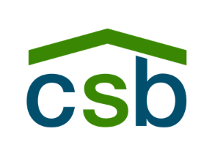
Community Shelter Board
Program Outcomes Plan (POP) Permanent Supportive Housing (PSH) Program Year: July 1, 2025 – June 30, 2026 (FY26)

Program Outcome Plan (POP) Instructions:

The POP template has six sections to complete. System benchmarks are pre-filled and standardized—do not edit these values. During the six-month lease-up period, applicable system fields may be marked “N/A.” For definitions and targets, see CSB Benchmarks for PSH below. The POP template is an Excel workbook provided with these instructions. The template has 6 sections that need to be completed.

A: Agency & Program Information

B: Capacity (Units)

C: Target Population

D: Variations from Standards

E: Projection goals

F: Signatures

When completing out the template, please do not skip over a section.
- Section A: Agency & Program Information: This section is where the agency and program information are entered. In the sample below, Community Shelter Board (CSB) is listed as both the agency and the program name. The program name used should accurately reflect the location of the PSH program. If the program represents a capacity expansion of an existing project, use the original program name followed by a “2.”
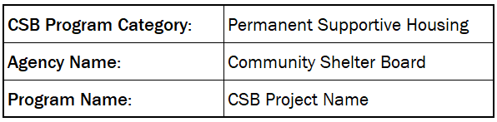
- Section B: Capacity (Units): This section is where the project’s capacity is listed in units. A unit is defined as a room or apartment if the PSH project operates as a scattered-site model. Do not list the total number of beds. If the project includes units designated for other disability categories that are not HUD Chronic Homeless (HUD CH) units, list those in this section as “Other Disabled Units.” Units classified as HUD Chronic Homeless (HUD CH) should be entered as they represent the program’s HMIS-designated capacity.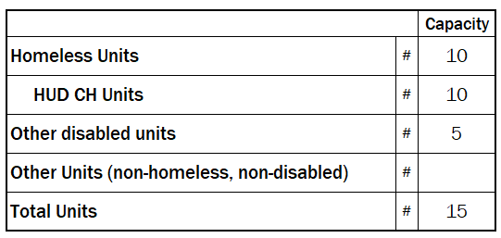

- Section C: Target Population: This section identifies the population the program is designed to serve. Place an “X” in the rightmost column next to the category that best reflects the program’s intended census. If the program serves multiple populations, mark all that apply and add clarifying notes if needed.
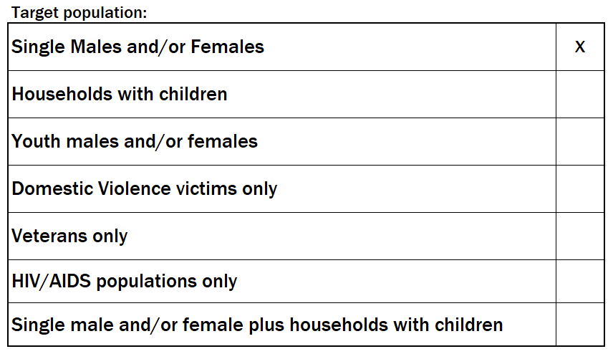
- Section D: Variations from Standards: If the program proposes standards that differ from CSB Performance Standards (system benchmarks), list and briefly justify them here. Include any related changes in projections.

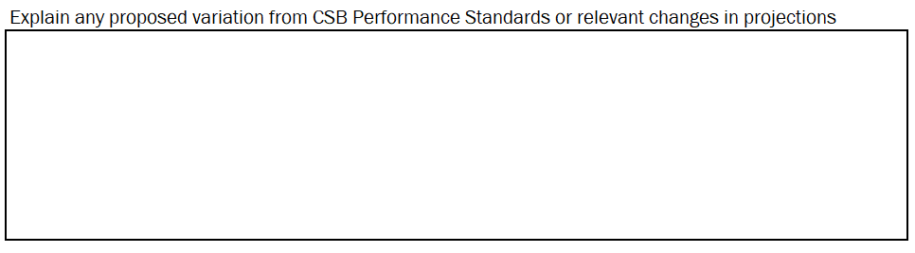
- Section E: Start-Up Projection goals: When a PSH program starts up, it has a six-month lease-up period to fill vacancies. During lease-up, only three measures apply: Households Served, Housing Stability, and Occupancy Rate. All other measures should be marked N/A. The example below reflects targets for a program that began in FY26.

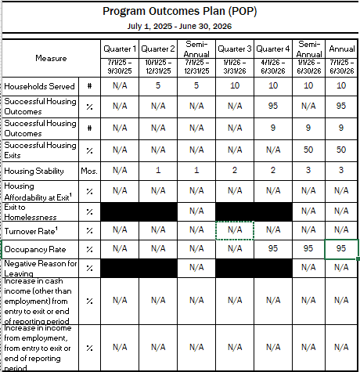

Section E: Projection goals (Continuation): After the six-month lease-up period ends, the program is given one additional quarter before turnover rate and all remaining measures are applied. Beginning the following quarter, the full CSB Program Performance Standards take effect (e.g., Successful Housing Outcomes—# and %, Exit to Homelessness, Turnover Rate, Occupancy Rate, Negative Reasons for Leaving, Income Increases, and Housing Affordability at Exit). The POP below reflects targets for a program operating beyond lease-up—in a steady state.

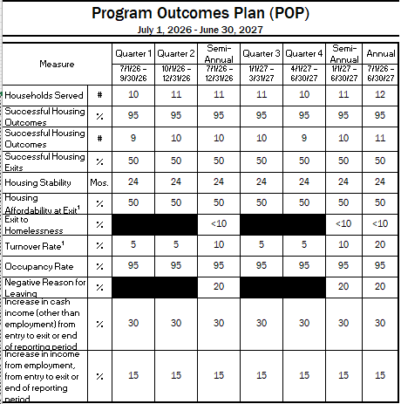

- Section C: Signatures: After the initial POP is created and agreed upon by all parties, the final step is to obtain signatures acknowledging that the goals listed in the POP are achievable for the program.

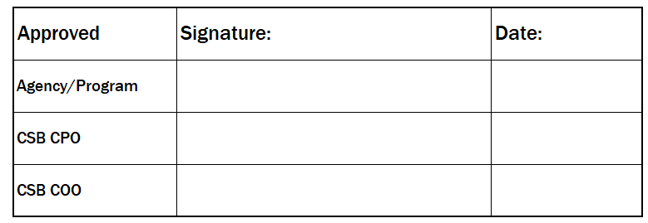

CSB Benchmarks for PSH:

CSB’s Program Performance Standards contain system measure benchmarks and corresponding goals for each measure. Listed below are the measures and goals for FY26. At the conclusion of each fiscal reporting period (July 1 through June 30), both measures and goals are reviewed to assess their continued relevance and alignment with community priorities. Any updates or revisions to measures or goals are finalized and published in December, with the new standards taking effect for the upcoming fiscal year.
CSB Program Performance Standards | Measurement | Annual Metrics
Efficient number of households served | Households served (#) | Set based on prior year(s) attainment and program capacity.
Access to resources/services to move to and stabilize housing | Housing Stability | At least 24 months for PSH.
 | Housing Affordability at Exit (%) (PSH only) | At least 50% of successful households have their housing affordability ratio, measured as cost of housing (rent and utilities) divided by the household’s income at exit, lower than 50%. (Monitored only.)
Basic needs met in a non-congregate environment | Successful housing outcomes (%) | At least 95% successful housing outcomes for PSH
Basic needs met in a non-congregate environment | Successful housing outcomes (#) | Calculated based on the Successful housing outcomes % measurement.
 | Successful housing exits (%)  (PSH only) | At least 50% of exits are successful housing outcomes.
Not re-enter the emergency shelter system | Exit to Homelessness (%) | Less than 10% of those who exit housing will return to homelessness within 180 days of exit.
Efficient and effective use of a pool of community resources | Cost per household | Cost per household will be consistent with budget. Evaluated annually and presented to the CoC.
Efficient and effective use of a pool of community resources | Cost per unit | Cost per unit will be consistent with budget. Evaluated annually and presented to the CoC.
Efficient and effective use of a pool of community resources | Program Occupancy Rate (%) | Full occupancy, at least 95%.
Efficient and effective use of a pool of community resources | Turnover Rate (%)  (PSH only) | An annual 20% turnover rate is desirable. (Monitored only.)
Efficient and effective use of a pool of community resources | Pass program certification | Provide access to resources and services to end homelessness.
CoC or HUD Standards | Negative Reason for leaving (%) | Less than 20% leave for non-compliance or disagreement with rules.
CoC or HUD Standards | Increase in cash income, other than employment, from entry to exit or end of reporting period (%) | At least 30% of adults will increase income from other sources than employment from entry to exit or end of reporting period.
 | Increase in income from employment, from entry to exit or end of reporting period (%) | At least 15% of adults will have increased employment income from entry to exit or end of reporting period.

Measure Definitions
- Housing Served (): Indicates volume of households served by the project. For emergency shelters, this number indicates the extent to which the project serves a proportional share of system demand. For supportive housing, the number correlates to capacity and unit turnover rates. For all other projects, the number measures project efficiency.

- Definition: The number of distinct households served by the project (including new and carryover) during the report period.

- Goal-setting methodology: Meet or exceed prior performance. If new project, the project must provide the rationale for planned goal.

- Annual projection: Multiply the project capacity by the projected annual turnover rate. In most cases, this percentage will be 20%. For example, if project capacity is 20, then annual projected households served would be 24 (20 x 1.2 = 24).

- Semi-annual projection: Multiply the project capacity by the projected semi-annual turnover rate. In most cases, this percentage will be 10%. For example, if project capacity is 20, then semi-annual projected households served would be 22 (20 x 1.1 = 22).

- Quarterly projection: Multiply the project capacity by the projected quarterly turnover rate. In most cases, this percentage will be 5%. For example, if project capacity is 20, then quarterly projected households served would be 21 (20 x 1.05 = 21).

- Reporting methodology: The number of distinct households served by the project during the report period. Distinct households served are identified by their last service record for the project entered into HMIS as of the end of the report period.
- Housing Stability (Months): The average length of time, measured in months, that distinct households reside in the Permanent Supportive Housing unit from entry to exit or end of report period.

- Definition: The average length of time, measured in months, that distinct households reside in the Permanent Supportive Housing unit from entry to exit or end of report period

- Goal-setting methodology: Permanent Supportive Housing: Meet or exceed CSB Board Ends Policy or local CoC standards; based on historical trends or anticipated performance.

- Reporting methodology: Measured using the average household length of stay in days (from entry to exit date or end of report period, if still a resident) divided by the average days per month (30.5 days). Measure is not calculated for those projects undergoing initial or expansion lease up.
  - Step 1: Calculate the total days that each household was housed by subtracting the Entry Date from the Exit Date or end of report period for all records.
  - Step 2: Determine the average length of stay for all the households by dividing the sum of total days housed by the number of distinct households served.
  - Step 3: Divide the average length of stay by 30.5, which is the average number of
  - days in a month.

- Housing Affordability at Exit (%): Indicates that the project is assisting households to obtain sufficient income to attain and maintain housing. A higher rate is considered positive.
  - Goal-setting methodology: Meet or exceed CSB Board Ends Policy. Monitored but not evaluated.

  - Definition: The percentage of distinct households that exited the project successfully during the report period with a housing cost that doesn’t exceed 50% of the household’s income.

  - Reporting methodology:
- Step 1: Determine the number of households that exited the project with a successful housing outcome during the reporting period.
- Step 2: For each household, calculate the percent of household income spent on housing (and utilities, if relevant) by dividing the household’s cost of rent (and utilities for Prevention and Rapid Re-housing) at exit with the household’s income at exit.
- Step 3: Count the number of households that spend 50% or less of their income on housing and utilities.
- Step 4: Divide the number in Step 3 by the number of successful housing exits in Step 1.

- Successful Housing Outcome/Successful Outcome (# and %): Permanent Supportive Housing: Indicates the project’s success in ending homelessness as measured by those who retain permanent housing or attain other permanent housing. Refer to Table 1 (Successful Housing Outcomes) for a complete list of housing outcomes.

- Definition: Successful Housing Outcomes for Permanent Supportive Housing project: the number of distinct households that remain in the Permanent Supportive Housing project or that exit the project during the report period for other permanent housing (as defined in Table 1 (Successful Housing Outcomes) and the percentage of total distinct households served this number represents.

- Goal-setting methodology: Meet or exceed CSB Board Ends Policy, HUD Standards, or prior performance.

- Reporting methodology: Sum the total number of distinct household exits during the report period with destinations that are considered successful housing outcomes and the number residing in Permanent Supportive Housing at the end of the report period. For the rate, divide this number of Successful Housing Outcomes by the total number of distinct households served during the report period. Note: Deceased households are not included in the count of households served or exited.
- Successful Housing Exit (%): Indicates the project’s success in ending homelessness as measured by those who attain permanent, independent housing. A higher number and rate are considered positive. Refer to Table 1 (Successful Housing Outcomes) for a complete list of housing outcomes.

  - Definition: Among distinct household exits, the percentage of that exit the project for other permanent housing as defined in Table 1 (Successful Housing Outcomes)

  - Goal-setting methodology: Meet or exceed prior performance.

  - Reporting methodology: The total number of distinct household exits during the report period with destinations that are considered successful housing outcomes divided by the total number of distinct households exited during the report period. Note: Deceased households are not included in the count of households exited.

- Exit to Homelessness (%): Indicates the project’s success in ending homelessness as measured by those who return to emergency shelter or the streets. A lower rate is considered positive.

  - Definition: The percent of households who do not maintain their housing and return to emergency shelter or the streets within 180 days of exit from the project.

  - Goal-setting methodology: At or below CSB Board Ends Policy or local CoC standards. Based on historical trends or anticipated performance.

  - Reporting methodology: The number of households who exit the project and enter shelter or street outreach within 180 days after exit or as of date of report, divided by the total number of distinct households served during the reporting period: Σ(Households that exited project and entered shelter or street outreach within 180 days) / total distinct households served.
    - Numerator
- Semi-annual cohort: Calculate the number of distinct households that exited within the previous semi-annual report period and entered shelter or street outreach within 180 days after exit or as of date of report.
- Annual cohort: Calculate the number of distinct households that exited within the first 180 days of the annual report period and entered shelter or street outreach within 180 days after exit or as of date of report.
    - Denominator
- Semi-annual cohort: Calculate the number of distinct households served within the previous semi-annual report period.
- Annual cohort: Calculate the number of distinct households served within the first 180 days of the annual report period.

- Project Occupancy Rate (%): Indicates efficient use of community resources. A high occupancy rate indicates project efficiency at turning over units and providing a project that is in demand.

- Definition: All Other: A percentage that reflects the average number of households residing in a project per night relative to the project capacity. For Outreach and Rapid Rehousing the project’s capacity is the same as the established carryover, or the point in time number of households served determined by the number of caseload carrying case managers and the caseload/staff.

- Goal-setting methodology: Meet or exceed CSB Board Ends Policy, local CoC standards, or prior performance. If new project, the project must provide the rationale for planned goal, including start-up.
- Reporting methodology: Total household units of service provided during the report period divided by the total days within the report period divided by the total project capacity. Measure is monitored, but not evaluated, for new projects during start-up.
  - Project Occupancy Number: ∑((exit date or end of report period – entry date or beginning of report period) + 1) / days in report period.
  - Rate: Project occupancy number (rounded to nearest whole number) divided by the project capacity.

- Turnover Rate (%): Turnover rate indicates the project’s effectiveness in providing stable housing. Rates are monitored but not evaluated.

- Definition: The rate at which units become vacant relative to the project capacity.

- Goal-setting methodology: Set based on prior performance. For new projects, CSB estimates the following turnover rates: Annual rate: 20%; Semi-annual rate: 10%; Quarterly rate: 5%. Monitored, but not evaluated.

- Reporting methodology: The total number of distinct households exited during a report period divided by the project capacity during the same report period.

9) Negative Reason for Leaving (%): A low rate of negative reasons indicates the system’s success in stabilizing a household in housing.

- Definition: The percentage of households that leave housing due to non-compliance or disagreement with the housing rules.
- Goal-setting methodology: Meet or below local CoC standards.
- Reporting methodology: The number of exited households during the report period
- who have “non-compliance with project” or “disagreement with rules/person” as their Reason for Leaving the system divided by the total number of households that exited during the reporting period.
10) Cost per Household / Cost per Unit: Annual cost efficiency measures, compared to budget.

Successful Housing Outcomes
HUD Destination | Does Head of household Control Housing? | Successful Housing Outcome?
101 = Emergency shelter, including hotel or motel paid for with emergency shelter voucher, or Host Home shelter | No | No
302 = Transitional housing for homeless persons (including homeless youth) - Huckleberry House – Transitional Living Program/TLP RYA and HFF Joint Transition To Home Transitional Housing component² | Varies | No  (Except for Emergency Shelters and Outreach)
439 = Permanent Supportive Housing - all PSH and CoC projects, HOME, HUD, CSB subsidized that DO NOT have a CMHA voucher, includes Rental Assistance projects – TRA or SRA | Yes | Yes
204 = Psychiatric hospital or other psychiatric facility | No | No
205 = Substance abuse treatment facility or detox center² | No | No
206 = Hospital or other residential non-psychiatric medical facility² | No | No
207 = Jail, prison or juvenile detention facility | No | No
8 = Client Doesn’t Know | No | No
9 = Client Prefers Not to Answer | No | No
410 = Rental by client, no ongoing housing subsidy – privately owned, market rent housing | Yes | Yes
411 = Owned by client, no ongoing housing subsidy | Yes | Yes
312 = Staying or living with family, temporary tenure (e.g., room, apartment or house)² | No | No
313 = Staying or living with friends, temporary tenure (e.g., room, apartment or house)² | No | No
314 = Hotel or motel paid for without emergency shelter voucher | No | No
215 = Foster care home or foster care group home² | No | No
116 = Place not meant for habitation (e.g., a vehicle, an abandoned building, bus/train/subway station/airport or anywhere outside) | No | No
17 = Other | No | No
118 = Safe Haven | No | No
421 = Owned by client, with ongoing housing subsidy | Yes | Yes
422 = Staying or living with family, permanent tenure | Yes¹ | Yes
423 = Staying or living with friends, permanent tenure | Yes¹ | Yes
24 = Deceased | No | No
225 = Long-term care facility or nursing home | No | No
426 = Moved from one HOPWA funded project to HOPWA PH | Yes | Yes
327 = Moved from one HOPWA funded project to HOPWA TH | No | No
329 = Residential project or halfway house with no homeless criteria | No | No
30 = No Exit Interview Completed | No | No
332 = Host home (non-crisis) | Yes | Yes
434 = Rental by client in a public housing unit | Yes | Yes
435 = Rental by client, with ongoing housing subsidy | Yes | Yes

Heads of household are determined to be in control of their housing if the lease/mortgage is in their name or if they otherwise have a written agreement that gives them a right to reside in their housing, such as a roommate agreement.
A successful housing outcome for Huckleberry House Emergency Shelter.

